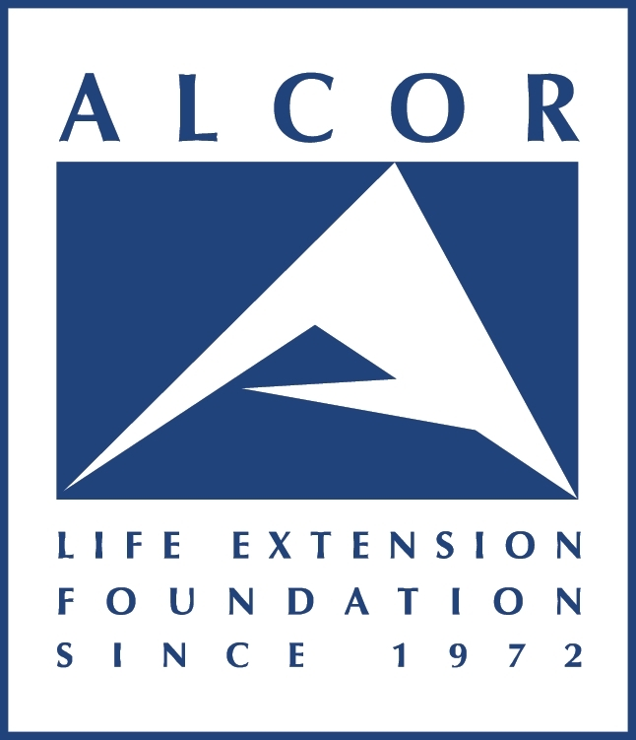

Cryonics Terminology

Experience has shown that choice of language is important for communicating the ideas of cryonics. The purpose of this guide is to help explain terminology that may be encountered during interviews or on our website.

Cryopreservation: Preservation of cells or tissue at cryogenic (below -80 degC) temperatures for an indefinite period of time.

Cryonics (not Cryogenics): Cryopreservation of humans with intent of future resuscitation. Laws currently require cryonics to be performed after legal death, but death is not part of the basic idea of cryonics. The purpose of cryonics is to preserve life.

Clinical Death: Absence of heartbeat or breathing.

Legal Death: A legal determination that continued life support is not appropriate or possible.

Standby: Preparations and onsite waiting for legal death prior to a cryonics case.

Revival or Resuscitation: Restoration of a person from cryopreservation to a healthy state.

Pronouncement: Pronouncement of legal death by a medical doctor or other qualified authority.

Transport: The phase of a cryonics procedure between pronouncement and treatment with cryoprotectant chemicals at Alcor.

Ischemia: Inadequate or absent blood circulation. Cryonics transport procedures reduce and treat ischemic injury, especially cerebral ischemic injury (ischemic injury to the brain).

Vitrification: Vitrification is an ice-free process in which over 60% of the water inside cells is replaced with protective chemicals. This completely prevents freezing during deep cooling.

Terms to Use with Care

Dead or Death: The permanent cessation of life. Cryonics is not a treatment for death. Cryonics is based on the premise that a person cannot be considered dead until their mind (brain) is physically destroyed, making resuscitation impossible by any means. Cryonics should never be compared with burial, cremation or other means of dealing with people who have experienced permanent death.

Suspended Animation: A great slowing of metabolism that is demonstrably reversible. Cryonics will not be suspended animation until it is reversible in practice, not just theory.

Terms to Avoid

Corpse: Alcor refers to those cryopreserved under its care as “patients”. Referring to them as “anatomical donors” is also accurate.

Resurrection or Coming back to life: See above preferred terms “revival” or “resuscitation”.

