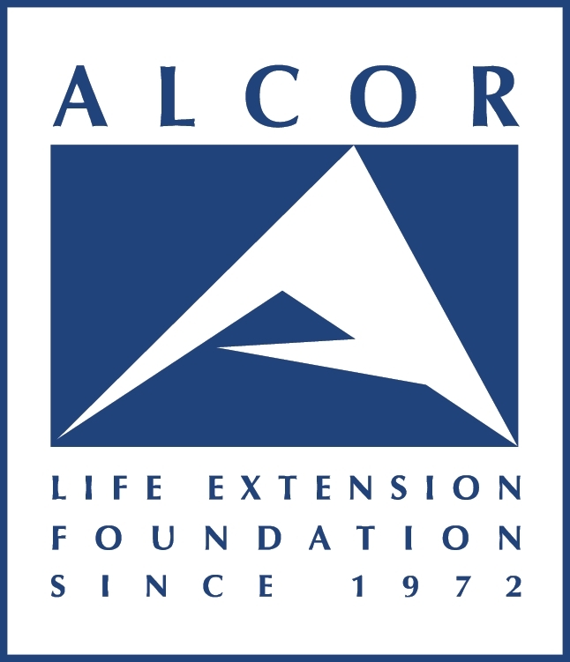
Top 5
Cryonics Myths
See “Cryonics Myths” page on our website for more:
https://www.alcor.org/library/myths-about-cryonics/

Myth 1: Cryonics freezes people
The current technology favored by Alcor is vitrification, not freezing. Vitrification is an ice-free process in which more than 60% of the water inside cells is replaced with protective chemicals. This completely prevents freezing. Instead of freezing, molecules just move more and more slowly until all chemistry stops at the glass transition temperature (approximately -124°C). Blood vessels have been reversibly vitrified, and whole kidneys have been recovered and successfully transplanted after cooling to -45°C while protected with vitrification chemicals.
Myth 2: Cryonics preserves dead people
The purpose of cryonics is to save the lives of living people, not inter the bodies of dead people. Death is a neurological process that begins after the heart stops. A stopped heart only causes death if nothing is done when the heart stops. Cryonics proposes to do something.
The purpose of cryonics is to intercept and stop the dying process within the window of time that it may be reversible in the future. The first few minutes of clinical death are certainly reversible, even today. There are good reasons to believe that this window will extend further in the future. That is why cryonics is sometimes implemented even long after the heart stops. Cryonics is not a belief that the dead can be revived. Cryonics is a belief that no one is really dead until their mind is destroyed, and that low temperatures have the potential to prevent this destruction.
Myth 3: Cryonics is an indulgence of rich people
Most of Alcor's membership is middle class and fund cryonics by life insurance. Cryonics is within reach of any healthy young person in the industrialized world who plans for it. For a young person, the lifetime cost of cryonics is no greater than that of smoking, cable TV, or regular eating out.
Myth 4: No reputable scientists or physicians support cryonics
More than 60 scientists and ethicists have signed a Scientists' Open Letter (https://www.biostasis.com/scientists-open-letter-on-cryonics/) endorsing the scientific basis of cryonics. Alcor also has reputable scientists and physicians within its membership and medical and scientific advisory boards, including scientists who have testified before the U.S. Congress on matters unrelated to cryonics, and a member of the U.S. National Academy of Sciences.
Myth 5: Cryonics conflicts with religion
The goal of cryonics is to overcome serious illness by preserving and protecting life. Cryonics is consistent with pro-life principles of both medicine and religion. Hypothermia victims have been revived after more than an hour without breathing, heartbeat, or brain activity. Deep cooling is sometimes used to "turn off" patients for long periods during neurosurgery when the heart must be stopped. Human embryos are routinely cryopreserved and revived. If cryonics works, it will work because it is fundamentally the same as these other forms of "suspended animation".

