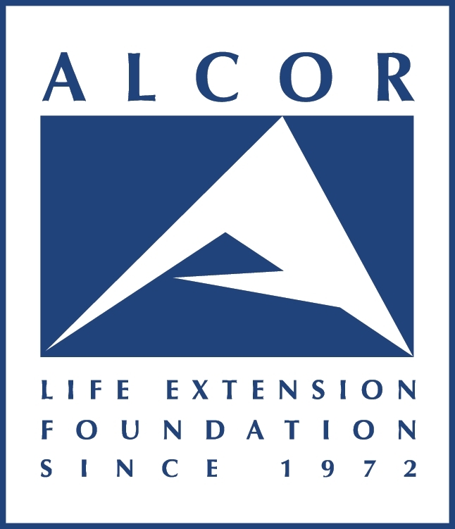

Fact Sheet

Corporate Office ALCOR Life Extension Foundation
7895 E. Acoma Dr., Suite #110
Scottsdale, AZ 85260
(480) 905-1906 phone
(480) 922-9027 fax
www.alcor.org

Chief Executive Officer Patrick Harris, MBA

Medical Response Director Blake Honiotes, BSN, RN, CCRN

The Alcor Life Extension Foundation, a nonprofit organization founded in 1972, is the world leader in cryonics and cryonics technology. Cryonics is the science of using ultra-cold temperatures to cryopreserve human life. The promise of cryopreservation has taken a leap forward with the introduction of vitrification (ice-free cryopreservation) to Alcor’s protocols.

Cryonics is based on the anticipation that technologically advanced scientific procedures and molecular nanotechnology will one day be available to revive cryopreserved humans and restore them to good health. With molecular nanotechnology, it is anticipated that cell-sized machines will be developed in the future to repair damage or cure aging and disease at the cellular level, including any potential damage from the cryopreservation process itself.

Alcor operates under the Uniform Anatomical Gift Act and performed its first human cryopreservation in 1976. Many people cover the cost of cryopreservation at Alcor services with affordable life insurance naming Alcor as the policy beneficiary. The cost of a whole body cryopreservation (entire body cryopreserved) is $200,000 and neuropreservation (brain only cryopreserved) is $80,000. While Alcor’s membership has traditionally been predominantly male, around age 40, and computer or science-oriented, membership has diversified in the 21st century to include more women and entire families.

Alcor offers “Standby” services whereby a trained team is available nearby a terminal person’s bedside or hospital room, ready to act if Alcor’s services are required. Similar to organ transplants, time is of the essence to give the person the best possible chance of receiving a good cryopreservation.

Today, Alcor is the only full-service cryonics organization in existence. Alcor has a medical advisory board, a scientific advisory board, a board of directors, and a patient care trust board. There are over 1300 Alcor members from around the world, and over 180 patients cryopreserved at Alcor.

